EXPERIENCE ARCHITECTURE / V1.0
The Highway One Project
An editorial digital documentary for Fender Highway One Stratocaster
Serial Number #10002368

━
Prepared for approval before design and implementation
02 July 2026 · São Paulo

1. The decision this document asks for
Approve the experience architecture—not the interface. This document defines the story, evidence model, asset roles, emotional rhythm, visual hierarchy and implementation guardrails. No production HTML, CSS or JavaScript has been written.
NORTH STAR The visitor must feel that they entered a carefully edited documentary about one documented instrument. Availability is a quiet epilogue, never the plot.

Recommendation
Proceed to implementation only after five approval gates are closed:
- Narrative: the eleven-part sequence (10 ACTs + epilogue) is approved.
- Evidence: captions and authenticity claims are approved by the named luthier/curators.
- Documentation: Fender confirmation is accepted as source evidence; the signed technical report remains to be supplied.
- Hero asset: approve the newly produced transparent-background cutout and its minimal reconstruction of areas formerly hidden by the wall support.
- Media policy: the owner accepts the proposed use of every file, including duplicate files as alternate delivery records rather than repeated visual moments.

Critical findings from the asset audit
Finding | Consequence | Decision
Fender e-mail received as two HEIC photographs. | ACT IV now has a primary manufacturer-source record tied to serial #10002368. | Use a faithful typeset transcription; redact personal address; preserve originals; clear the confidentiality notice before public release.
No signed luthier report/PDF was present. | ACT V–VII may show inspection imagery but must not overstate conclusions. | Use “inspection record”; add signed report when supplied.
No true transparent guitar cutout was supplied. | A dedicated hero asset was required. | Resolved in pre-production: fender-highway-one-hero-cutout-v1.png; pending visual approval.
Three HEICs have byte-identical “2” duplicates. | Using both visibly would feel accidental. | Preserve both in archive; display once; record duplicate provenance.
Technical JPGs are 864×1152 or 1152×864. | Strong evidence, weak fullscreen hero material. | Use in dossier with captions and controlled zoom, never editorial hero.
Best cinematic video is the performance clip. | It carries human energy but its original audio must not autoplay. | Autoplay muted; offer an explicit sound control.

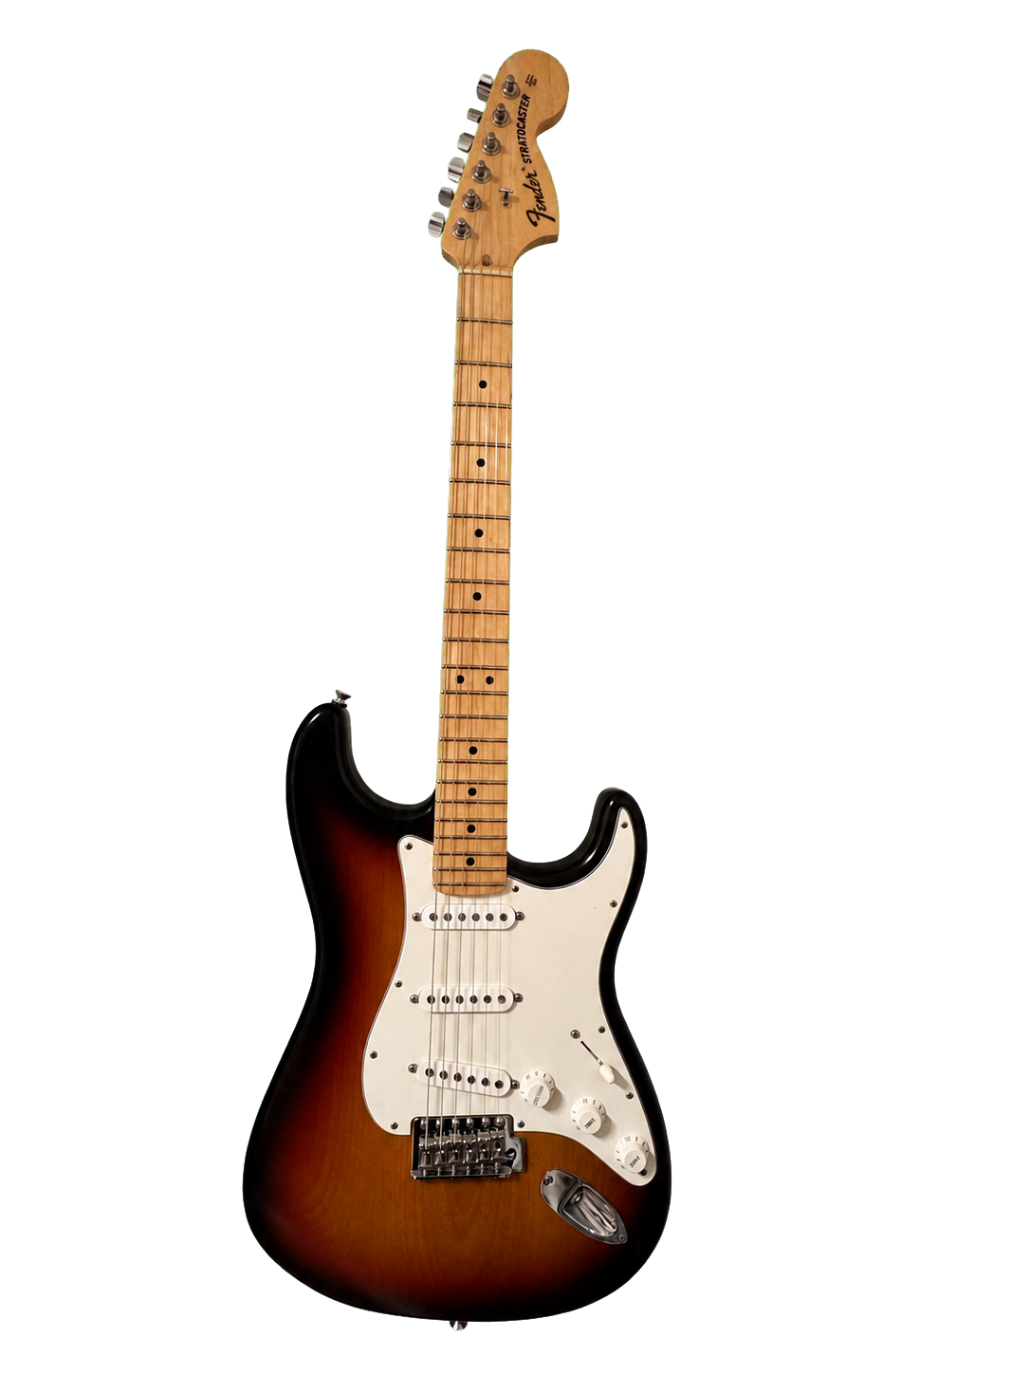
Prepared hero asset — transparent PNG derived from IMG_7615; pending visual approval.

2. Experience thesis
The experience is built on a single dramatic transformation: object → lineage → individual character → proof → stewardship. Each ACT changes the visitor’s question.
Phase | Visitor question | Emotional register
Encounter | What is this instrument? | Curiosity, reverence
Context | Why did Highway One matter? | Recognition, historical interest
Portrait | What makes this particular guitar compelling? | Desire without sales pressure
Verification | Can the story be trusted? | Confidence, scrutiny
Custody | What happens next? | Responsibility, possibility

EDITORIAL PRINCIPLE Beauty earns attention; evidence earns trust. Promotional imagery and technical evidence never occupy the same visual chapter, grid or lightbox.

3. Complete site map
Layer | Destination | Navigation behavior
Primary narrative | ACT I–X + The Next Chapter | One continuous scroll; discreet chapter progress appears only after ACT I.
Evidence branch | Authentication Dossier | Entered from ACT VI; technical-only lightbox and caption index.
Media branch | Photo Gallery / Video Gallery | Separate galleries; no cross-category recommendations.
Document branch | Documentation | Verified downloads with source, date, type and checksum.
Utility overlays | Contents, accessibility, soundtrack, contact | Non-disruptive overlays; keyboard and screen-reader accessible.

Suggested URL model: / (narrative); /dossier/ (technical evidence); /gallery/photos/; /gallery/video/; /documentation/. The visual experience can feel continuous while preserving meaningful, indexable URLs.

Narrative spine
Order | Chapter | Purpose
01 | ACT I — The Instrument | Silent encounter; title, provenance line, serial.
02 | ACT II — A Fender Called Highway One | Historic context and the Upgrade generation.
03 | ACT III — The Instrument | Editorial portrait of this specific guitar.
04 | ACT IV — Factory Confirmation | Manufacturer-source evidence, once supplied.
05 | ACT V — The Investigation | Introduce people, method and chain of custody.
06 | ACT VI — Authentication Dossier | Organized technical evidence.
07 | ACT VII — The Details | Interpret small observations with measured language.
08 | ACT VIII — Photo Gallery | Contemplative promotional/editorial photography only.
09 | ACT IX — Video Gallery | Motion studies and optional performance sound.
10 | ACT X — Documentation | Verified source downloads.
11 | The Next Chapter | Stewardship invitation and contact.

4. Emotional journey
Moment | Intensity | Designed feeling | Design instrument
ACT I | 4/5 | Awe and stillness | Near-black field, isolated instrument, one invitation.
ACT II | 3/5 | Intellectual curiosity | Measured timeline, archival typography, quiet comparisons.
ACT III | 5/5 | Desire and intimacy | Largest editorial imagery, slow image reveals.
ACT IV | 3/5 | Relief and trust | Document-like white/ivory island inside the dark experience.
ACT V | 3/5 | Human confidence | Names, roles, method; no celebrity styling.
ACT VI | 4/5 | Forensic attention | Dense but calm evidence system, numbered figures.
ACT VII | 4/5 | Discovery | Observation → visual proof → cautious interpretation.
ACT VIII | 5/5 | Visual pleasure | Fullscreen editorial cadence and controlled lightbox.
ACT IX | 4/5 | Presence and tactility | Muted loops, sound only by consent.
ACT X | 2/5 | Closure and confidence | Document register and download integrity.
Epilogue | 3/5 | Responsibility, possibility | Spare language, one contact path.

The curve deliberately alternates spectacle and proof. Consecutive high-intensity sections would flatten the experience; the quieter document and investigation chapters reset attention.

5. Narrative choreography by ACT

ACT I — The Instrument
Narrative job: Encounter, not explanation.
- Black prelude; the guitar emerges over 1.2–1.6 seconds.
- Project title appears after the object, followed by the provenance line and serial.
- “Begin the Story” is the only action; no persistent menu before engagement.
Preferred media: the prepared transparent asset fender-highway-one-hero-cutout-v1.png, derived from IMG_7615 with background/support removal.
Justification: withholding navigation protects the first impression and establishes documentary pacing.

ACT II — A Fender Called Highway One
Narrative job: Give the object a lineage.
- Origin and market position.
- Made-in-USA proposition.
- Finish and aging behavior, using only claims supported by catalog/service sources.
- 2006 Upgrade inflection.
- Highway One vs. earlier Highway One vs. American Standard.
- End of line: state verified chronology; do not claim a specific discontinuation cause without evidence.
Media: licensed/official historic material only; otherwise use typography, timeline and catalogue excerpts with permission.
Justification: historical literacy turns the guitar from a commodity into a cultural artifact.

ACT III — The Instrument
Narrative job: Shift from model history to this serial-numbered individual.
- Full-body portrait.
- Body and sunburst.
- Headstock and maple neck.
- Bridge, contours and back.
- Quiet closing identification: #10002368.
Media: IMG_7640/41, 7642/43, 7644/48, 7645/46, 7639, 7647, 7649/50. Select one near-duplicate per beat.
Justification: this is the emotional apex before evidence begins.

ACT IV — Factory Confirmation
Narrative job: Introduce primary-source authority.
- A short editorial explanation.
- A typeset document transcription preserving sender role, date and substantive message.
- Redact the recipient’s personal e-mail from the public layer.
- State the confirmed identity: serial #10002368; model 0111162300; Highway One Stratocaster Upgrade MN 3TS; date of manufacture 03/2010.
- Clear boundary between “confirmed by Fender” and interpretation.
- Keep the photographed originals in the controlled documentation archive; public release requires clearance because the message carries a confidentiality notice.
Media: IMG_7656.heic and IMG_7657.heic as controlled source records. No screenshot treatment in the narrative and no fabricated letterhead.
Justification: a restrained document surface makes authority legible without imitating official stationery.

ACT V — The Investigation
Narrative job: Make the method and people visible.
- Curadoria — Prof. Fabiano Duarte / @fabisustenido.
- Inspeção Técnica — Luthier Sr. Elpidio Denis Biondi.
- Scope, date, environment and limits of inspection.
- Chain-of-custody transition into evidence.
Media: one workshop/portrait image only if supplied; otherwise typographic identities.
Justification: trust should attach to accountable roles and a method, not vague claims.

ACT VI — Authentication Dossier
Narrative job: Turn the website into a navigable case file.
- Overview and evidence index.
- Body and neck identifiers.
- Pickups and electronics.
- Bridge and hardware.
- Assembly marks and labels.
- Serial/headstock records.
- Completeness and limitations statement.
Media: all 32 luthier JPGs, plus technical details IMG_7647, IMG_7650 and relevant macro videos only if labeled as later records.
Justification: technical images receive captions, figure numbers and zoom because their value is evidentiary, not decorative.

ACT VII — The Details
Narrative job: Translate evidence into careful observation.
- Finish over nut/frets, if shown.
- Finish pigmentation and aging.
- Wood movement and fit.
- Shielding and wire memory.
- Solder and component markings.
- For every point: observation → image → interpretation → confidence/limit.
Media: selected dossier figures reused as cited references, never as uncaptioned beauty shots.
Justification: separating observation from inference prevents visual confidence from becoming an authenticity overclaim.

ACT VIII — Photo Gallery
Narrative job: Return to contemplation after forensic density.
- Fullscreen rhythm: whole → angle → body → headstock → hardware → back.
- Lightbox preserves full frame and metadata.
- Duplicate files appear once visually, with archival duplication noted.
Media: editorial subset of HEIC files only; no luthier photography.
Justification: the visual palate cleanser restores emotion without erasing the evidence just seen.

ACT IX — Video Gallery
Narrative job: Let surface, scale and sound become temporal.
- Chapter A: Neck & fret motion studies.
- Chapter B: back of neck and junction.
- Chapter C: case and stewardship objects.
- Chapter D: headstock orbit and played performance.
- Autoplay muted, loop, inline; explicit “Hear the instrument” on performance only.
Media: all 11 videos, grouped by purpose. No global autoplay audio. The optional soundtrack must never replace instrument audio without labeling.
Justification: grouping weakens repetition and turns short clips into a deliberate motion essay.

ACT X — Documentation
Narrative job: Close the proof loop.
- Document register.
- Type, issuer, date, status and checksum.
- Downloads: Fender confirmation, signed report, original/curated photos, supporting records.
- Unverified or missing items remain visibly unavailable; never use placeholder downloads.
Media: IMG_7614 (single visual occurrence) may introduce retained accessories; original documents when supplied.
Justification: integrity metadata makes the archive useful beyond the screen.

THE NEXT CHAPTER
Narrative job: Convert ownership into stewardship.
- Fifteen-year history statement, verified against dates.
- Invitation to a future guardian.
- One contact action and privacy note.
- Credits and provenance footer.
Media: quiet closing crop or silhouette; no product grid, price or scarcity device.
Justification: the language preserves dignity and lets availability emerge as consequence.

6. Visual hierarchy and art direction
Tier | Role | Treatment
T0 — Hero object | The guitar as singular presence | 70–76% viewport height; isolated; no competing UI.
T1 — Chapter title | Orientation and rhythm | Cormorant Garamond/Canela fallback; 56–96 px desktop, fluid clamp.
T2 — Editorial statement | One idea per screen | Short lines, 24–40 px, max 18–24 words.
T3 — Evidence title | Searchable case-file structure | Inter Medium, figure numbering, strong labels.
T4 — Caption/metadata | Source, date, observation | Inter 13–15 px, muted, never hidden behind hover.
T5 — Controls | Agency without noise | Inter Medium; low contrast at rest, high contrast on focus.

Image grammar
- Editorial field: edge-to-edge or generous black/white negative space; no visible figure numbers.
- Dossier field: fixed frame, source label, figure number, caption, zoom and related evidence.
- Never place a luthier image inside an editorial mosaic or promotional lightbox.
- Never place a polished beauty photograph as proof of an internal component.
- Do not crop serials, codes, solder joints, dates or the inspected edge of a part.

Motion grammar
Only opacity, transform and subtle scale are permitted. Standard reveal: 650–900 ms; hero reveal: 1200–1600 ms; parallax range: max 4–6% of viewport. Respect prefers-reduced-motion by removing parallax, autoplay and nonessential loops.

Color grammar
Token | Value | Use
Obsidian | #050505 | Narrative background and cinematic frames.
Paper | #F5F5F2 | Primary text and document surfaces.
Muted | #9A9A9A | Captions and secondary metadata; contrast must be tested.
Archive gold | #B08D57 | Kickers, active chapter and fine rules only.
Hairline | #242424 | Dividers and dossier structure.

7. Media distribution strategy
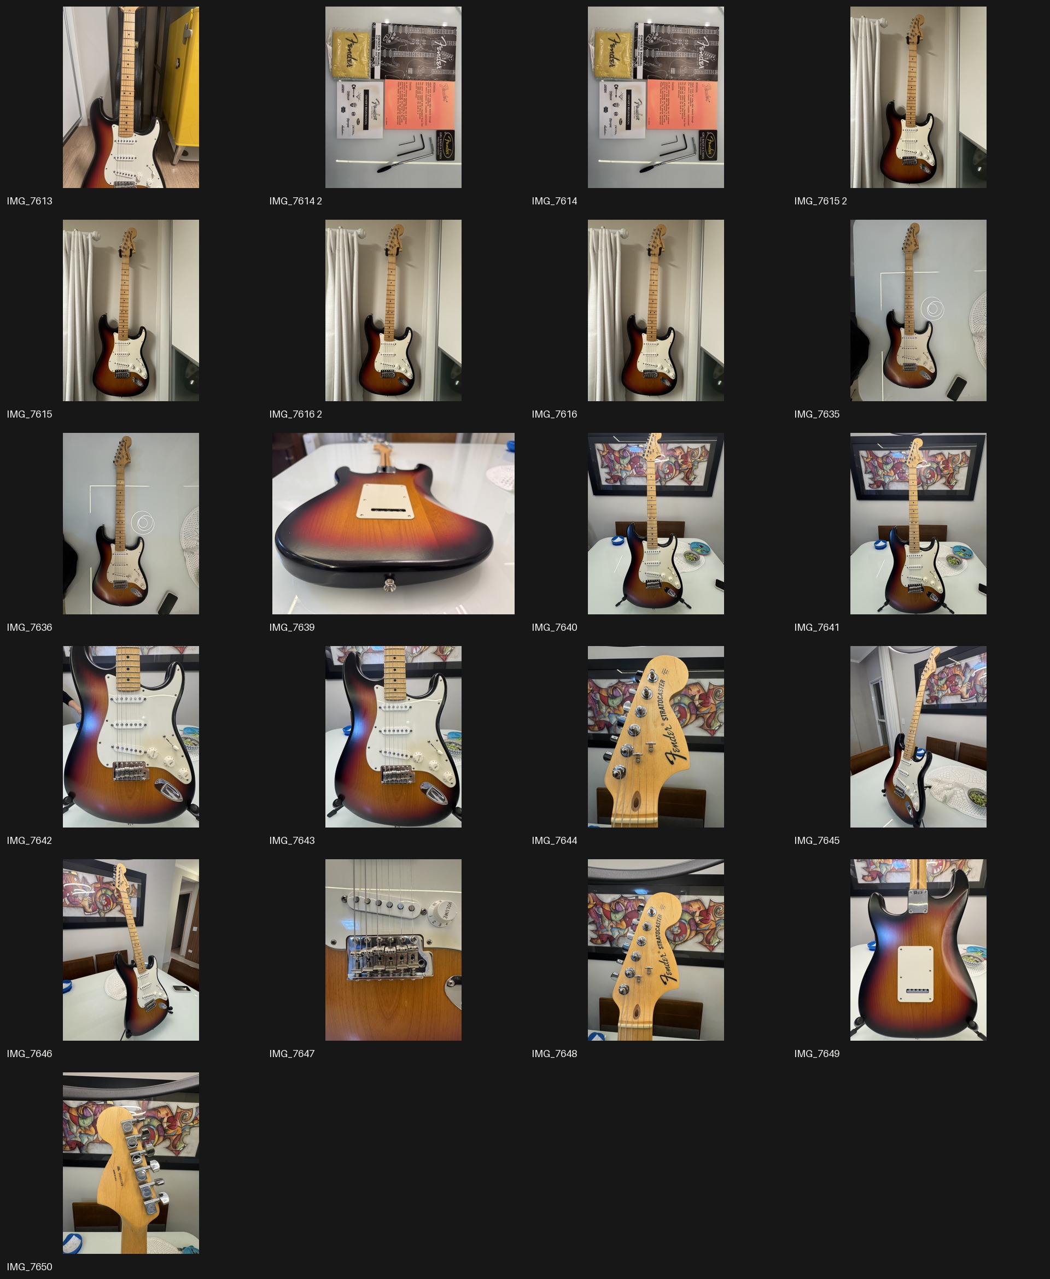
Audit contact sheet — source HEIC set. It contains editorial, documentary/accessory and detail records; not every file is promotional.
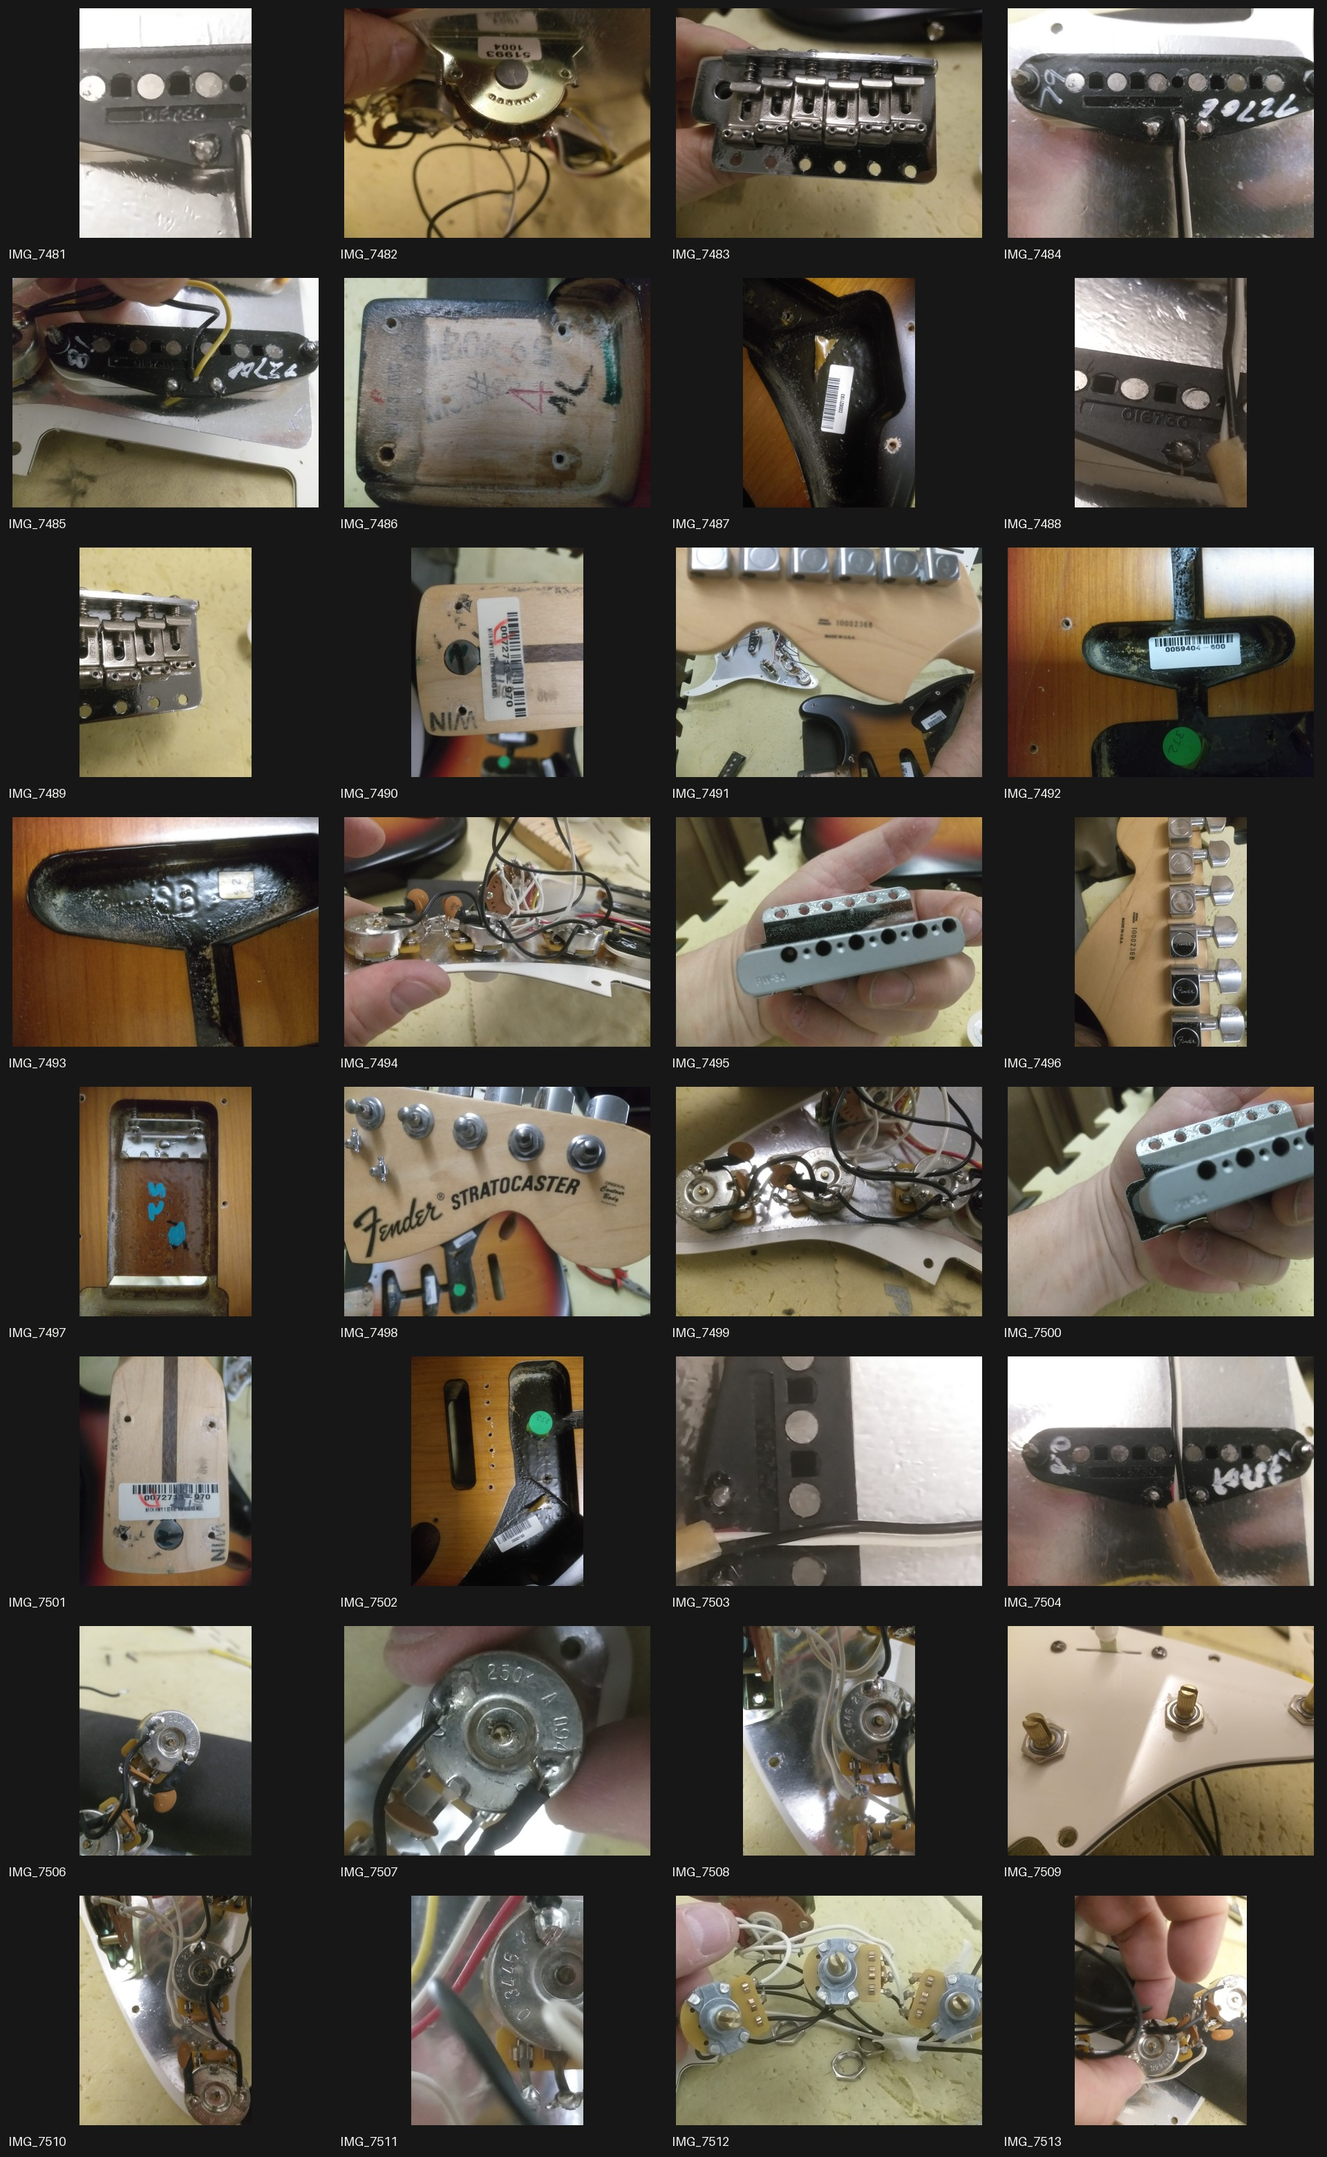
Audit contact sheet — 32 luthier images. Technical evidence only.
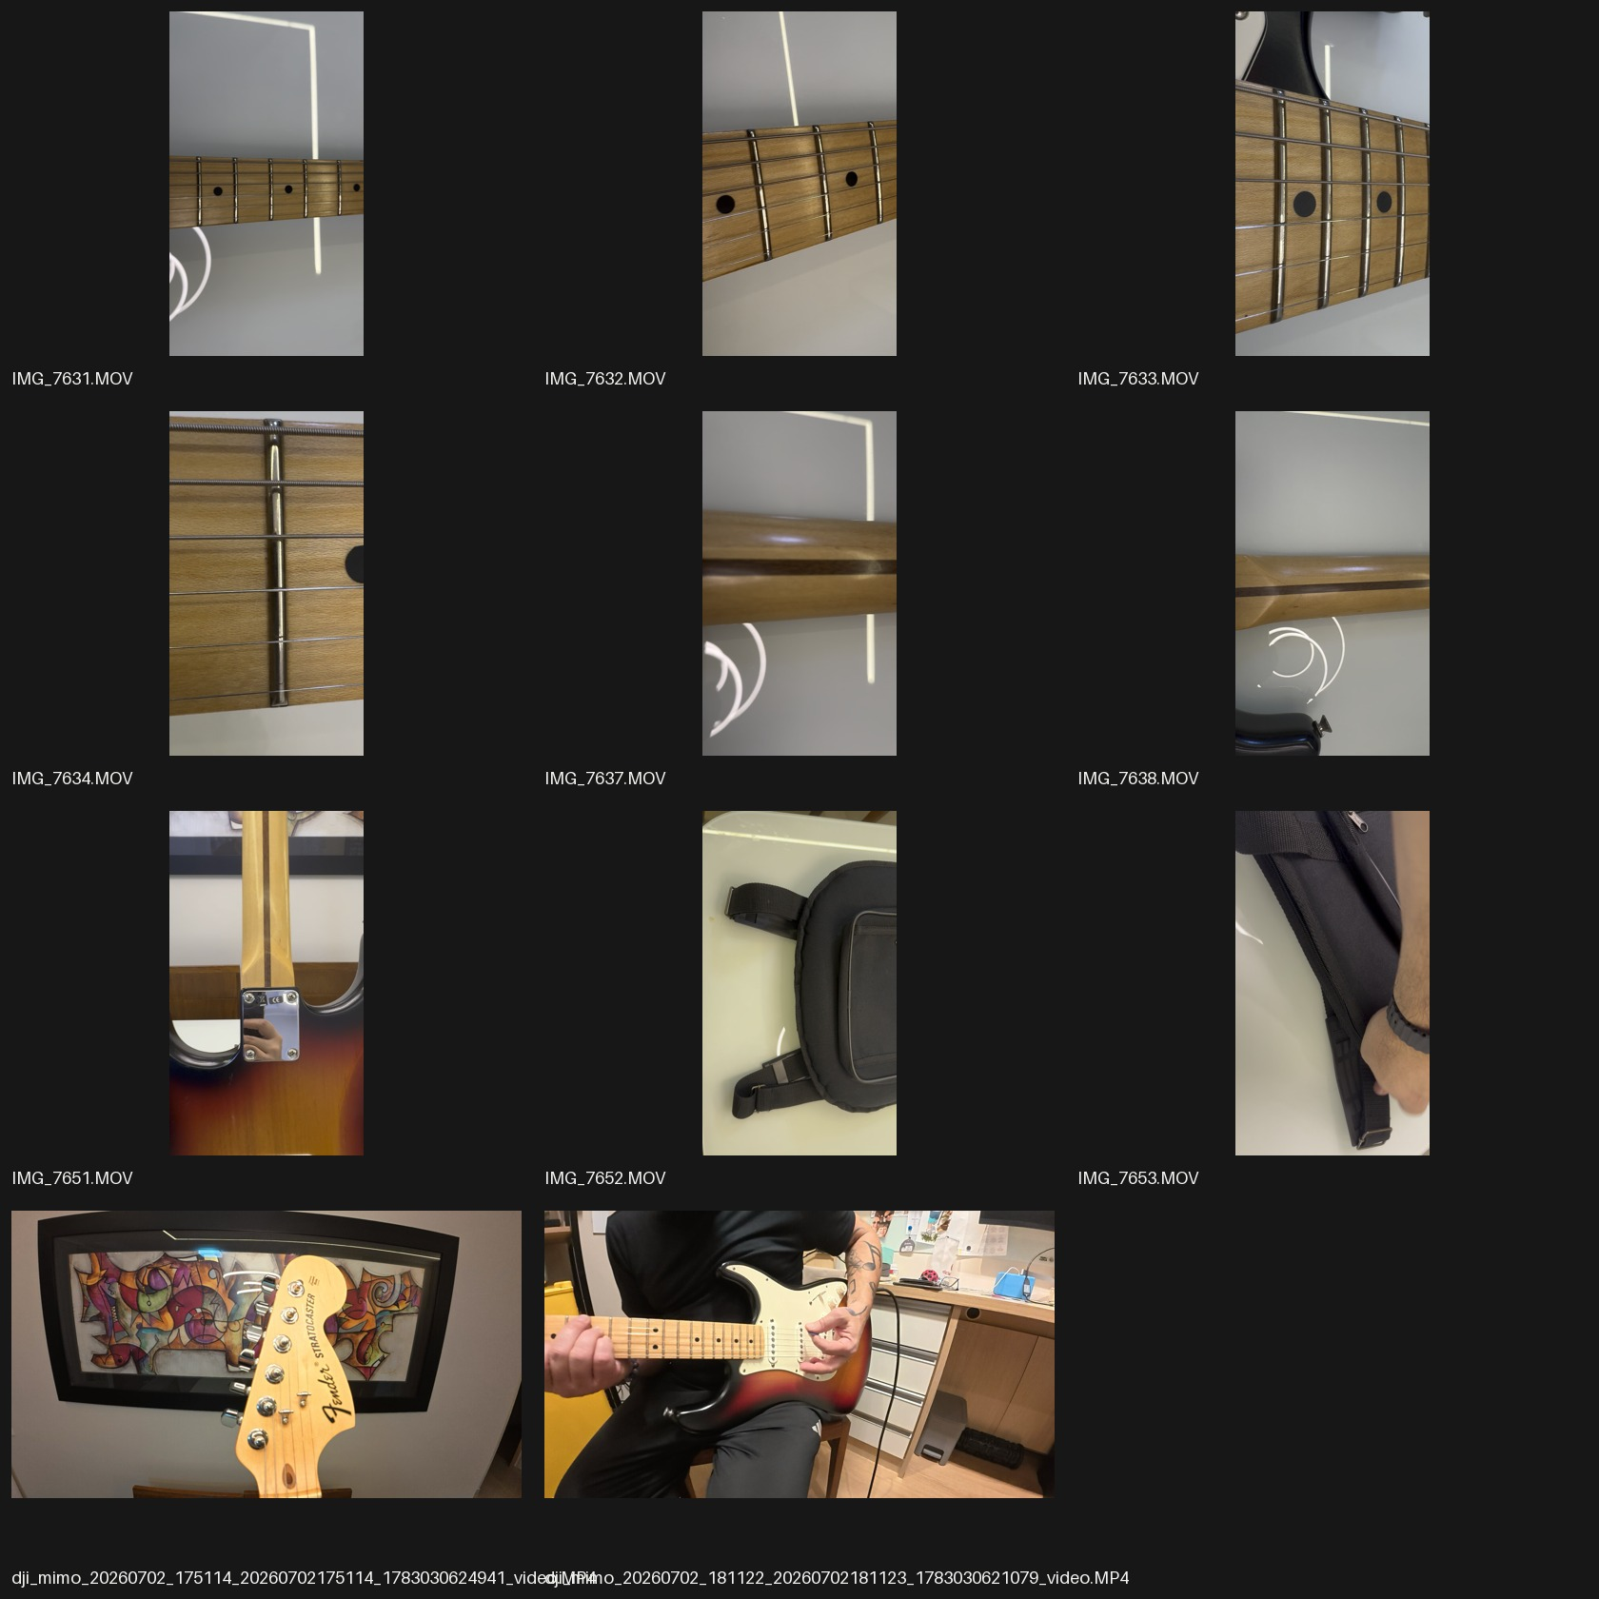
Audit contact sheet — representative Quick Look frame for each of the 11 videos.

Quality and role verdict
The HEIC set is technically large (mostly 4032×3024; IMG_7613 and IMG_7639 are 5712×4284), but many frames include domestic background elements, reflections or casual staging. Resolution alone does not make a hero. The luthier set is lower resolution and visually utilitarian, which is appropriate inside a captioned dossier. The strongest motion asset is the played performance; the other clips work best as grouped macro studies rather than eleven equal “hero videos.”

8. File-by-file inventory — HEIC photographs
File | Category | Observed content | Best use
IMG_7613.HEIC | Documentary | Guitar inside open gig bag | ACT X / retained-case record; not hero.
IMG_7614.HEIC | Documentation | Accessories, cards, tools and printed material | ACT X opening still life.
IMG_7614 2.HEIC | Duplicate | Byte-identical copy of IMG_7614 | Archive only; do not display twice.
IMG_7615.HEIC | Editorial-support | Full guitar leaning, vertical | ACT III transition or gallery after retouch.
IMG_7615 2.HEIC | Duplicate | Byte-identical copy of IMG_7615 | Archive only.
IMG_7616.HEIC | Editorial-support | Second full-guitar leaning frame | ACT III alternate; choose against 7615.
IMG_7616 2.HEIC | Duplicate | Byte-identical copy of IMG_7616 | Archive only.
IMG_7635.HEIC | Editorial-support | Full front on reflective table | Gallery; crop cautiously around reflections.
IMG_7636.HEIC | Editorial-support | Second full front on reflective table | Gallery alternate.
IMG_7639.HEIC | Editorial-detail | Rear body / sunburst close perspective | ACT III body contour beat.
IMG_7640.HEIC | Editorial | Full front on stand | ACT III principal full portrait.
IMG_7641.HEIC | Editorial | Near-duplicate full front on stand | Gallery alternate; select one for narrative.
IMG_7642.HEIC | Editorial | Front body close-up | ACT III finish/pickguard beat.
IMG_7643.HEIC | Editorial | Near-duplicate front body close-up | Gallery alternate.
IMG_7644.HEIC | Editorial-detail | Headstock front | ACT III identity beat.
IMG_7645.HEIC | Editorial | Three-quarter full guitar | ACT III spatial portrait.
IMG_7646.HEIC | Editorial | Second three-quarter full guitar | Gallery alternate.
IMG_7647.HEIC | Technical-detail | Bridge and controls close-up | ACT VI/VII cited figure; not promo gallery.
IMG_7648.HEIC | Editorial-detail | Headstock front, wider | Gallery / headstock sequence.
IMG_7649.HEIC | Editorial-detail | Rear body and neck plate | ACT III back/contour beat.
IMG_7650.HEIC | Technical-detail | Rear headstock / tuners / serial area | ACT VI identity record.

9. File-by-file inventory — luthier evidence
File | Evidence subject | Dossier placement
IMG_7481.JPG | Pickup base / stamped or molded code | Pickups — code record.
IMG_7482.JPG | Potentiometer rear and marking | Electronics — component code.
IMG_7483.JPG | Tremolo bridge underside / saddles | Hardware — bridge construction.
IMG_7484.JPG | Pickup base with handwritten marks | Pickups — inspection mark.
IMG_7485.JPG | Pickup base, wires and markings | Pickups — wiring context.
IMG_7486.JPG | Neck pocket with marks | Body & neck — pocket evidence.
IMG_7487.JPG | Body cavity and barcode label | Body — factory label.
IMG_7488.JPG | Pickup base code detail | Pickups — code close-up.
IMG_7489.JPG | Bridge saddle/underside detail | Hardware — bridge detail.
IMG_7490.JPG | Neck heel barcode/date label | Body & neck — neck identifier.
IMG_7491.JPG | Disassembled guitar, serial visible | Overview — chain-of-custody frame.
IMG_7492.JPG | Back cavities / tremolo cover labels | Body — cavity labels.
IMG_7493.JPG | Rear cavity molded mark and label | Body — cavity close-up.
IMG_7494.JPG | Loaded pickguard wiring | Electronics — assembly overview.
IMG_7495.JPG | Pickup bobbin/base profile | Pickups — construction detail.
IMG_7496.JPG | Rear headstock and serial | Identity — serial record.
IMG_7497.JPG | Tremolo cavity / block | Hardware — tremolo cavity.
IMG_7498.JPG | Headstock logo and body disassembly | Identity — branding/context.
IMG_7499.JPG | Potentiometers and wiring | Electronics — solder/wire layout.
IMG_7500.JPG | Pickup base profile and markings | Pickups — construction detail.
IMG_7501.JPG | Neck heel label and markings | Body & neck — neck identifier close-up.
IMG_7502.JPG | Body cavity label and shielding | Body — shielding/label overview.
IMG_7503.JPG | Pickup base / wire junction close-up | Pickups — solder detail.
IMG_7504.JPG | Pickup base / lead wires | Pickups — lead orientation.
IMG_7506.JPG | Potentiometer code overview | Electronics — code record.
IMG_7507.JPG | Potentiometer code macro | Electronics — code close-up.
IMG_7508.JPG | Potentiometer installed / wiring | Electronics — installed context.
IMG_7509.JPG | Pickguard switch/control openings | Electronics — pickguard hardware.
IMG_7510.JPG | Potentiometer wiring close-up | Electronics — solder/wire detail.
IMG_7511.JPG | Potentiometer stamped code macro | Electronics — code close-up.
IMG_7512.JPG | Three-pot wiring assembly | Electronics — assembly overview.
IMG_7513.JPG | Potentiometer and solder inspection | Electronics — inspection detail.

CAPTION RULE These descriptions identify what is visible, not what it proves. Final captions and any authenticity conclusion require sign-off by the luthier.

10. File-by-file inventory — videos
File | Observed subject | Editorial use
IMG_7631.MOV | Fretboard/frets macro | Video Gallery: Neck Study I; muted loop.
IMG_7632.MOV | Fretboard/frets macro | Neck Study II; pair with 7631.
IMG_7633.MOV | Fretboard/frets closer macro | Neck Study III; evidence-adjacent caption.
IMG_7634.MOV | Extreme fret/board detail | ACT VII detail or gallery chapter.
IMG_7637.MOV | Back of maple neck | Video Gallery: Finish Study I.
IMG_7638.MOV | Back of neck / transition toward body | Finish Study II.
IMG_7651.MOV | Neck plate / body junction | Video Gallery: Construction Junction.
IMG_7652.MOV | Gig bag / case detail | Stewardship objects; short bridge clip.
IMG_7653.MOV | Gig bag handling/detail | Stewardship objects; pair with 7652.
dji_mimo_…175114…video.MP4 | Headstock movement/orbit | Cinematic opener for Video Gallery.
dji_mimo_…181122…video.MP4 | Musician playing the instrument | Video Gallery finale; muted autoplay, explicit instrument-audio opt-in.

11. Proposed clean asset structure
- assets/source-originals/zip-extract/ — immutable extracted package, including __MACOSX metadata.
- assets/source-originals/luthier/ — immutable 32-image inspection set.
- assets/images/editorial/ — selected and color-managed HEIC derivatives.
- assets/images/documentary/ — accessories, gig bag and retained records.
- assets/images/dossier/body-neck/; pickups/; electronics/; hardware/; identity/ — evidence by subject.
- assets/videos/motion-studies/; performance/; stewardship/ — video grouping.
- assets/documents/fender/; luthier/; provenance/ — verified originals and web-safe downloads.
- assets/derivatives/avif/; webp/; posters/; thumbnails/ — generated delivery files only.
- assets/manifests/assets.json — filename, original hash, category, caption, rights, ACT, alt text and derivative links.
Original filenames and hashes remain immutable. Human-friendly filenames are created only for derivatives; the manifest preserves traceability.

11A. Fender documentation received
File | Source role | Confirmed content | Public treatment
IMG_7656.heic | Fender Consumer Relations e-mail, page/photograph 1 | Serial #10002368; model #0111162300; Highway One Stratocaster Upgrade MN 3TS; DOM 03/2010; principal specifications. | Do not publish as screenshot. Create faithful editorial transcription; redact personal recipient address.
IMG_7657.heic | Continuation, page/photograph 2 | Gig bag; nitrocellulose finish; ’70s headstock; U.S. source; introduced 07/2006; discontinued 10/2011; sender signature. | Controlled original/download only after confidentiality clearance.

FACTORY CONFIRMATION The record correlates the submitted serial number to the stated model and factory specification. It does not, by itself, certify that every current component remains original; that conclusion belongs to the technical inspection.

12. Interaction, accessibility and performance contract
Concern | Architecture requirement
Autoplay | Muted + playsinline; pause when offscreen; user-visible pause; disable for reduced motion/data preference.
Sound | Never autoplay. Instrument audio and optional soundtrack are separate, labeled controls.
Keyboard | All chapter navigation, galleries, lightboxes, media and contact paths work without pointer.
Screen readers | Semantic headings; figure/figcaption; transcripts or descriptive summaries for every video.
Contrast | AA minimum; muted #9A9A9A must be tested at actual size on #050505.
Images | Meaningful alt text; technical captions retain codes in visible text, not only alt.
Loading | Hero preload only; remaining media lazy; responsive srcset; AVIF/WebP with source fallback.
Video delivery | Poster first; compressed H.264/MP4 baseline plus WebM where justified; no 11 simultaneous decodes.
SEO | Each chapter has indexable copy; Item/CreativeWork schema only when facts are verified.
Integrity | Download checksums, source/issuer labels and no dead placeholder links.

13. Historical research and content guardrails
The architecture supports deep historical storytelling, but publication copy must distinguish verified record, reasonable interpretation and oral history.
- Use the 2010 Fender Frontline catalogue as the primary period anchor for model names, variants and contemporaneous positioning.
- Use Fender service/parts documentation for component nomenclature and the existence of Upgrade variants.
- Do not state that Fender discontinued Highway One for a specific reason. Fender’s current general support article says models are most often discontinued for lack of demand; that is not model-specific proof.
- Do not reproduce historic photography without a documented license. Catalogue excerpts may also require permission.
- Treat the serial as an identifier, not sufficient proof of originality or completeness.

Working source register
- Fender Support — Highway 1 Stratocaster HSS Upgrade Parts List 0111760
https://support.fender.com/en-us/knowledgebase/article/KA-01503
- Fender Support — Why did Fender discontinue a product?
https://support.fender.com/hc/en-us/articles/42508986708379-Why-did-Fender-discontinue-a-product
- Fender Frontline 2010 catalogue / price list (archived copy; verify rights before reproduction)
https://guitar-compare.com/wp-content/uploads/2019/08/Fender-2010-Catalog-Pricelist.pdf

14. Approval checklist
- ☐ Approve the 10 ACTs + epilogue and their order.
- ☐ Approve strict separation of editorial and technical galleries.
- ☐ Approve the proposed role of every photograph and video.
- ☐ Confirm whether byte-identical duplicates should remain archive-only.
- ☐ Approve the editorial transcription and redaction policy for the received Fender confirmation.
- ☐ Confirm that the Fender e-mail may be quoted/published despite its confidentiality notice, or obtain permission.
- ☐ Supply signed luthier report and final technical conclusions.
- ☐ Confirm dates, biographies, role labels and @fabisustenido attribution.
- ☐ Approve the prepared transparent hero cutout, including the minimally reconstructed areas formerly hidden by the support.
- ☐ Confirm media ownership/licensing and permission to publish faces and workshop imagery.
- ☐ Approve optional audio model: muted autoplay; user-initiated instrument audio; optional soundtrack never automatic.
- ☐ Approve public contact channel and privacy handling.
- ☐ Approve bilingual strategy (English narrative / Portuguese dossier, or a complete language switch).
IMPLEMENTATION GATE Approval of this document authorizes the design/implementation phase. Until then, the project remains intentionally at architecture stage.

Appendix A — Audit accounting
Asset class | Files present | Unique visual/media records | Audit note
HEIC photographs | 21 | 18 | 3 byte-identical “2” duplicates.
Luthier JPG photographs | 32 | 32 | All technical evidence.
Videos | 11 | 11 | 9 MOV + 2 MP4.
ZIP metadata | 32 AppleDouble entries | 0 editorial assets | Preserved as extraction metadata; never published.
Fender e-mail photographs | 2 HEIC | 1 two-part record | Received; includes personal address and confidentiality notice.
Signed luthier report/PDF | 0 | 0 | Required input remains missing.

Inspection method: complete ZIP extraction; file-type and dimension scan; MD5 duplicate check; HEIC conversion for visual review; contact-sheet review of every photograph; Quick Look representative-frame review of every video; comparison against the supplied creative brief. The audit does not substitute for frame-by-frame editorial logging, color grading, audio review or formal luthier sign-off.

Appendix B — Decision log
Decision | Chosen direction | Reason
Experience format | Editorial documentary, not landing/product/sales page | Matches preservation and collector context.
Navigation | Hidden before ACT I engagement; chapter rail afterward | Protects encounter without sacrificing orientation.
Hero | Prepared transparent cutout derived from IMG_7615 | Removes domestic background and support while preserving the singular-object concept.
Dossier styling | Case-file system with figure captions | Makes evidence legible and prevents promotional mixing.
Gallery strategy | Curated sequence + complete archive access | Uses every asset while avoiding visible repetition.
Video sound | Muted by default; explicit opt-in | Meets consent, accessibility and brief requirements.
Availability | Only in epilogue | Preserves story-first tone.

